EXPT NO: 5 | Classification using K-Nearest Neighbors (KNN) and  Decision Tree
DATE: 19.02.2026

PRE-LAB QUESTIONS (PROVIDE BRIEF ANSWERS TO THE FOLLOWING QUESTIONS)
- What is the intuition behind the K-Nearest Neighbors algorithm?

K-Nearest Neighbors assumes that data points with similar features are located close to each other in feature space. A new observation is classified by identifying its K closest training examples and assigning the most frequent class (or average value) among those neighbors.

- Why is KNN called a “lazy learner”?

KNN is called a lazy learner because it does not build an explicit training model. Instead, it stores all training data and performs computations only at prediction time, calculating distances to neighbors when a new query instance appears.

- How does the choice of K influence model performance?

The value of K directly affects bias and variance. A small K may overfit noise and produce high variance. A large K smooths decision boundaries, reducing variance but increasing bias. Choosing K carefully improves generalization performance.

- Why is feature scaling important in KNN?

KNN relies on distance calculations such as Euclidean distance. If features are on different scales, larger-scale features dominate distance computation. Feature scaling, like normalization or standardization, ensures balanced influence of all features and improves prediction reliability.

- What is a Decision Tree classifier?

A Decision Tree classifier is a supervised learning algorithm that recursively partitions data based on feature values. It creates a tree-like structure where internal nodes represent feature tests, branches represent outcomes, and leaf nodes assign final class labels.

- What is meant by tree depth?

Tree depth refers to the maximum number of splits from the root node to the deepest leaf. Greater depth increases model complexity and ability to capture detailed patterns, but it also raises the risk of overfitting.

- What is overfitting in Decision Trees?

Overfitting occurs when a decision tree becomes too complex and models noise in the training data instead of underlying patterns. This typically happens with deep trees, leading to high training accuracy but poor generalization to unseen data.

- Difference between entropy and Gini index?
Entropy measures impurity using logarithmic probabilities from information theory.
Gini index uses squared class probabilities, is computationally simpler, and often slightly faster in practice.

SCENARIO 1 – K-NEAREST NEIGHBORS (KNN)

Problem Statement
Predict whether a tumor is benign or malignant based on medical measurements.

Dataset (Kaggle – Public)
Breast Cancer Dataset
Dataset Link: https://www.kaggle.com/datasets/yasserh/breast-cancer-dataset

Target Variable: Diagnosis (Benign / Malignant)
Input Feature:
• Radius
• Texture
• Perimeter
• Area
• Smoothness

IN-LAB TASKS (KNN Classification)
- Import required Python libraries.
- Load the Breast Cancer dataset.
- Perform data inspection & preprocessing.
- Encode target labels.
- Apply feature scaling (very important for KNN).
- Split dataset into training and testing sets.
- Train a KNN classifier.
- Experiment with different values of K.
- Predict diagnosis labels.
- Evaluate performance using:
• Accuracy
• Precision / Recall / F1 Score
- Identify misclassified cases.
- Analyze model sensitivity to K.

Visualization
• Confusion Matrix
• Accuracy vs K Plot
• Decision Boundary (using two features)

Code and Output

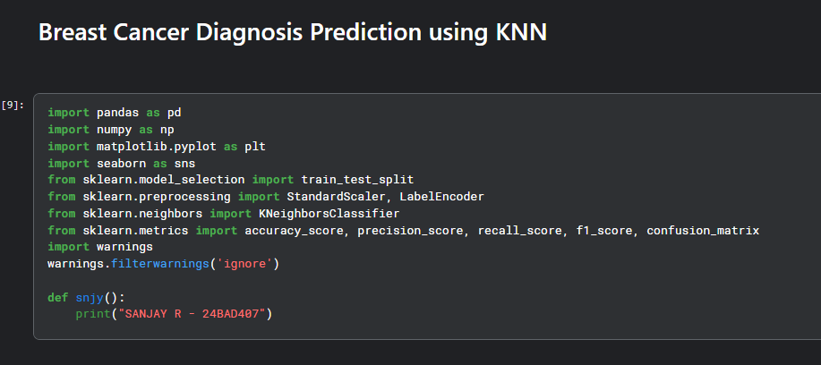
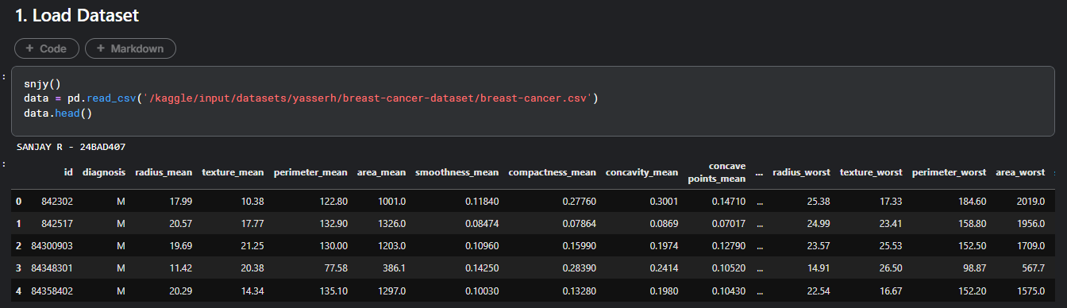
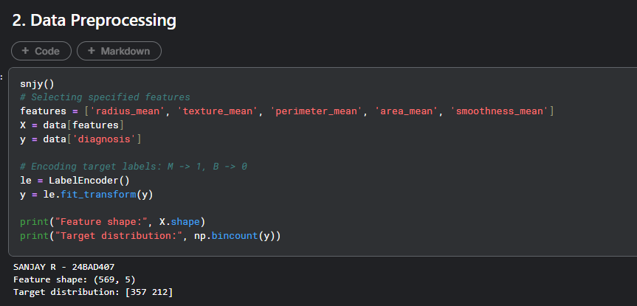
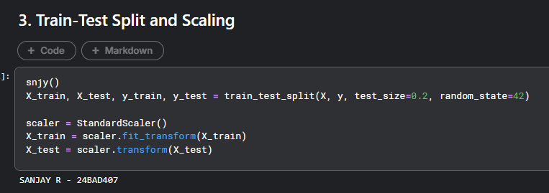

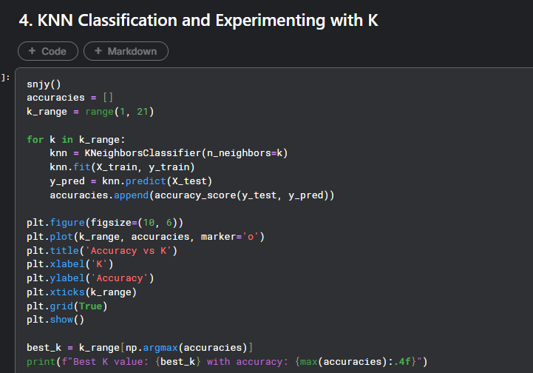
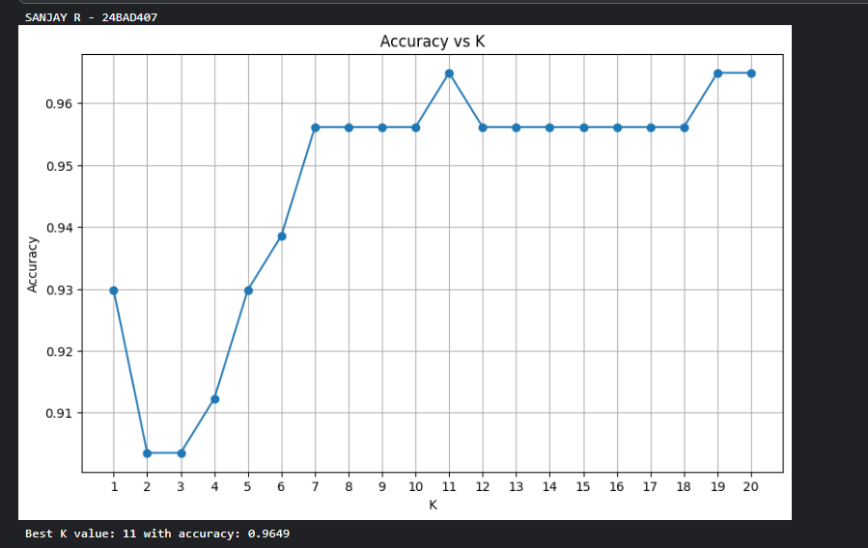
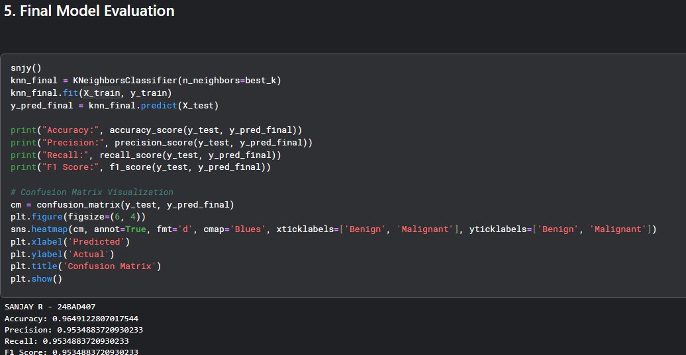
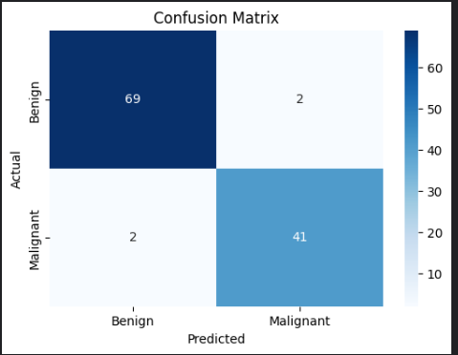
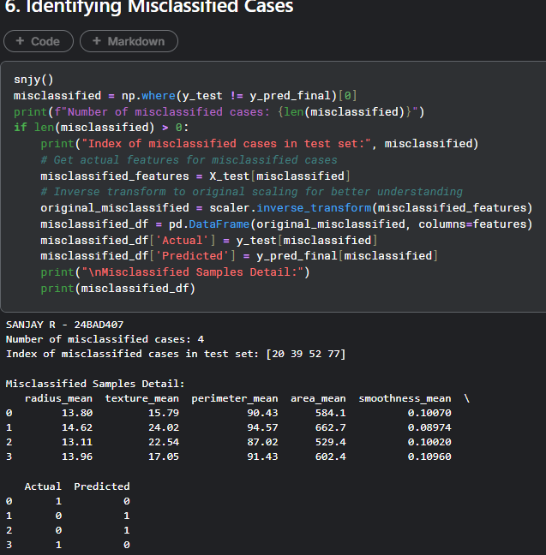
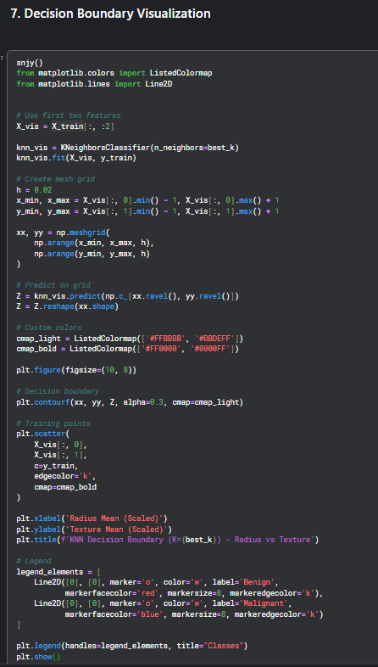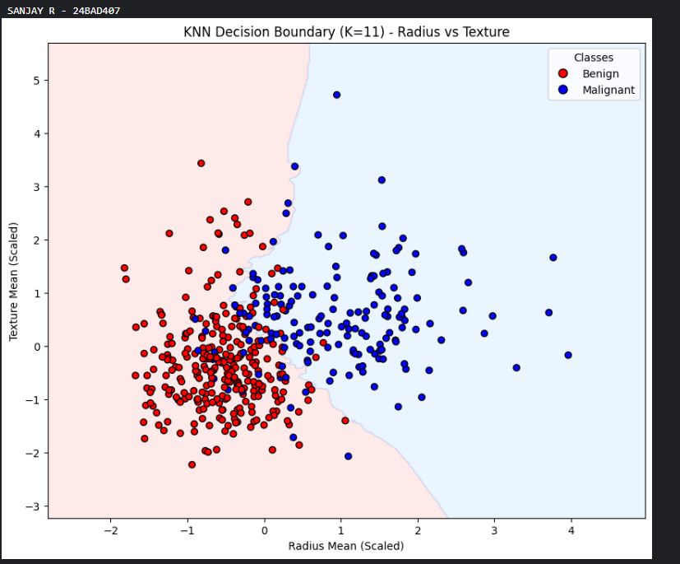
SCENARIO 2 – DECISION TREE CLASSIFIER

Problem Statement
Predict whether a loan application should be approved or rejected.

Dataset (Public / Standard Dataset)
Loan Prediction Dataset
Dataset Link: https://www.kaggle.com/datasets/ninzaami/loan-predication

Target Variable: Loan Status (Approved / Rejected)
Input Features
• Applicant Income
• Loan Amount
• Credit History
• Education
• Property Area

IN-LAB TASKS (Decision Tree Classification)
- Import required Python libraries.
- Load the Loan Prediction dataset.
- Perform preprocessing:
• Handle missing values
• Encode categorical variables
- Split dataset into training and testing sets.
- Train a Decision Tree classifier.
- Experiment with tree depth / pruning.
- Predict loan status.
- Evaluate performance using:
• Accuracy
• Precision / Recall / F1 Score
- Analyze feature importance.
- Detect overfitting behavior.
- Compare shallow vs deep trees.

Visualization
• Confusion Matrix
• Tree Structure Plot
• Feature Importance Plot

Code & Output
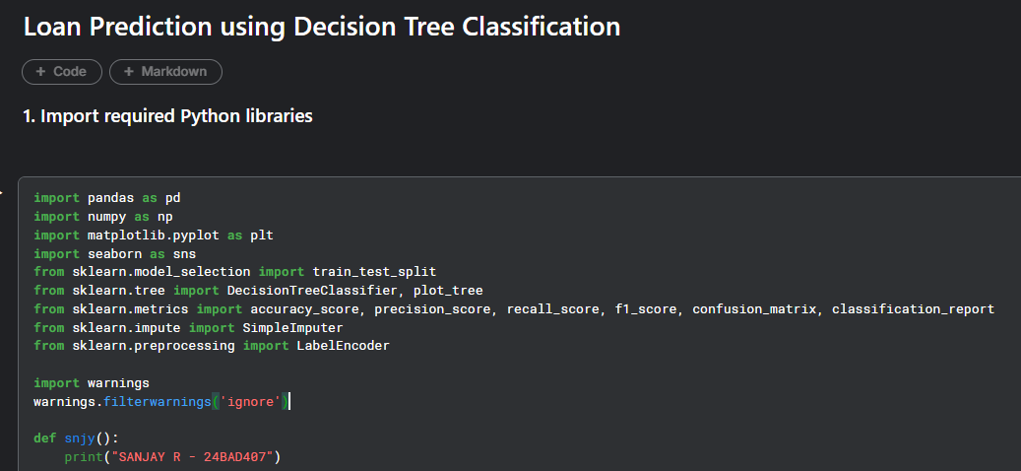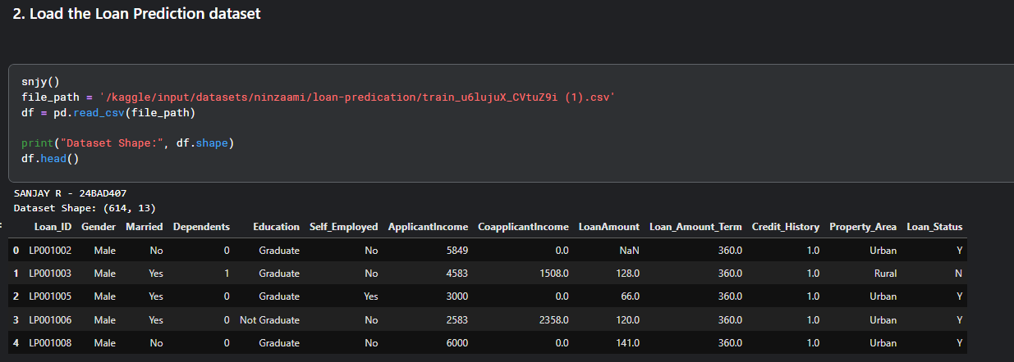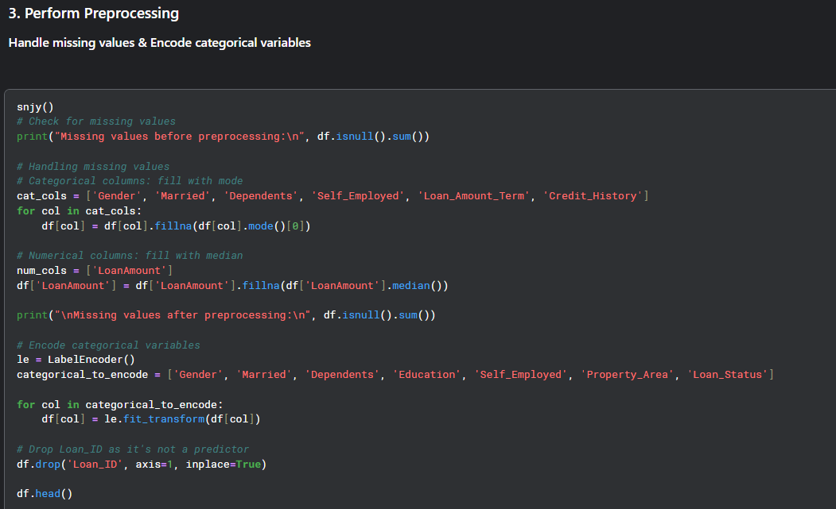
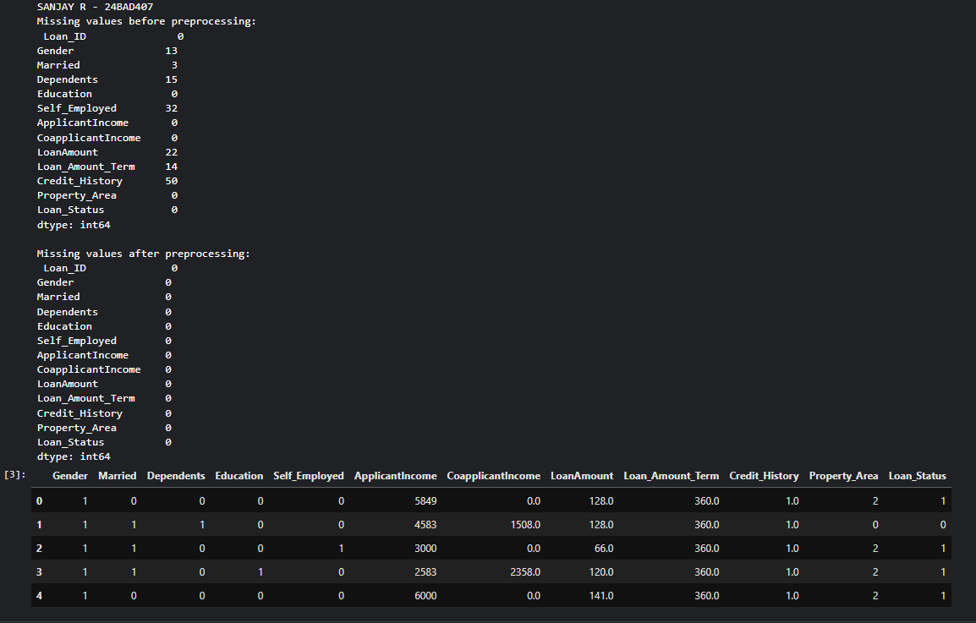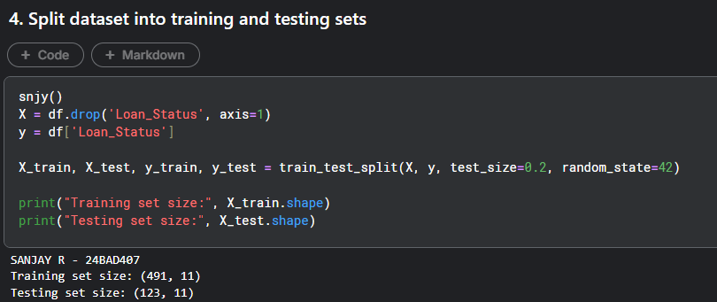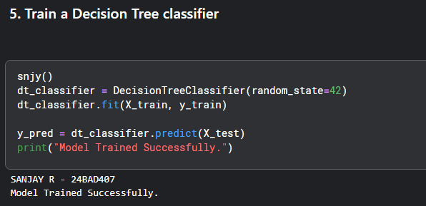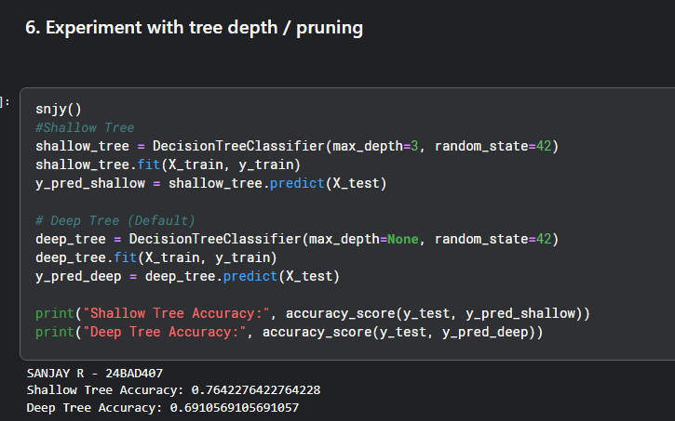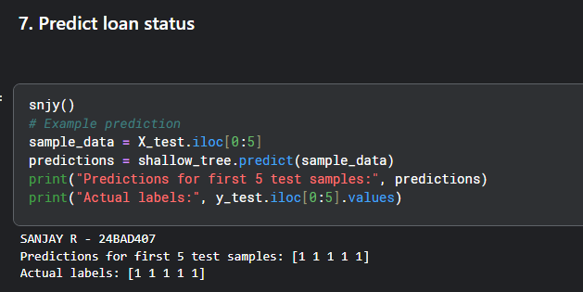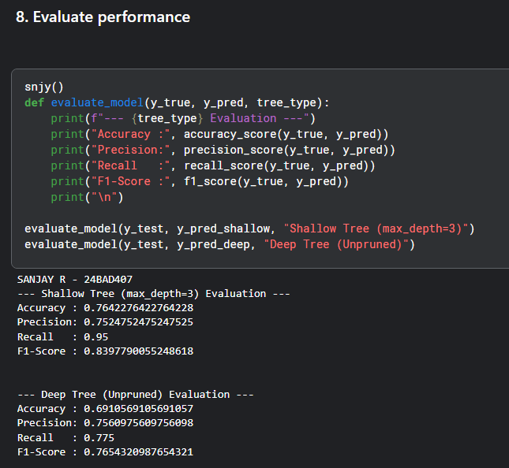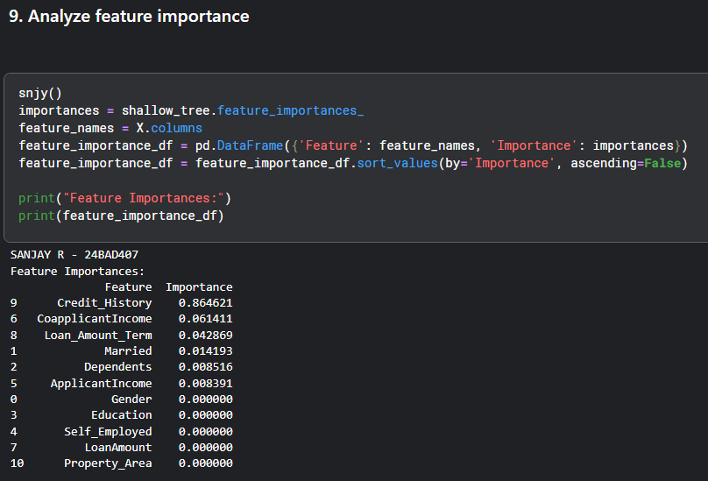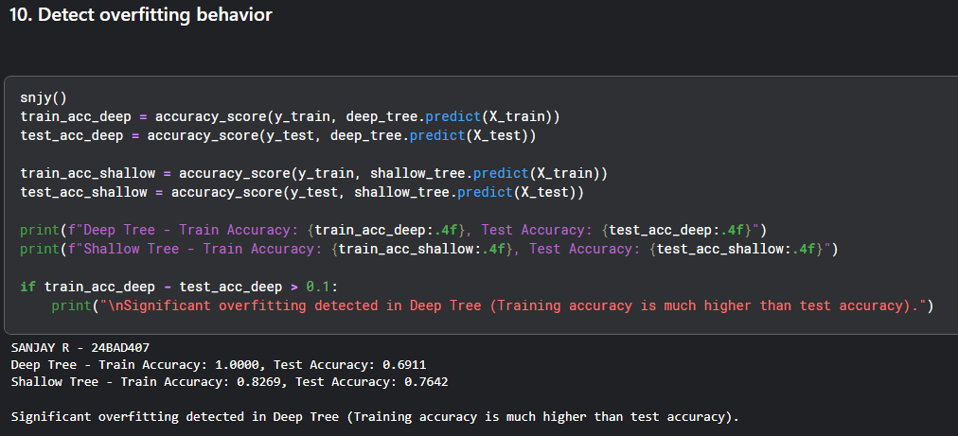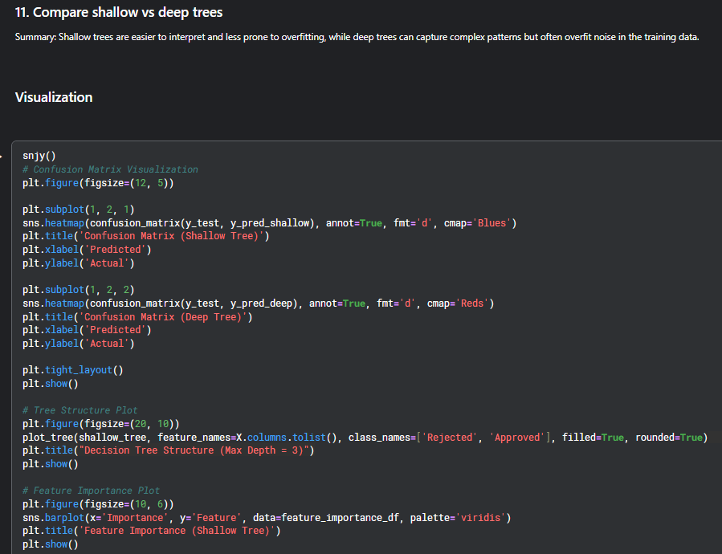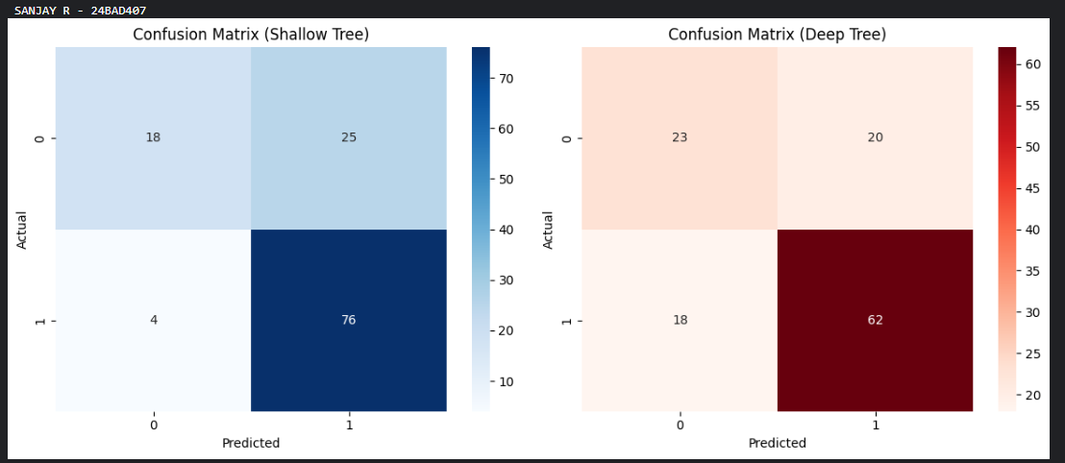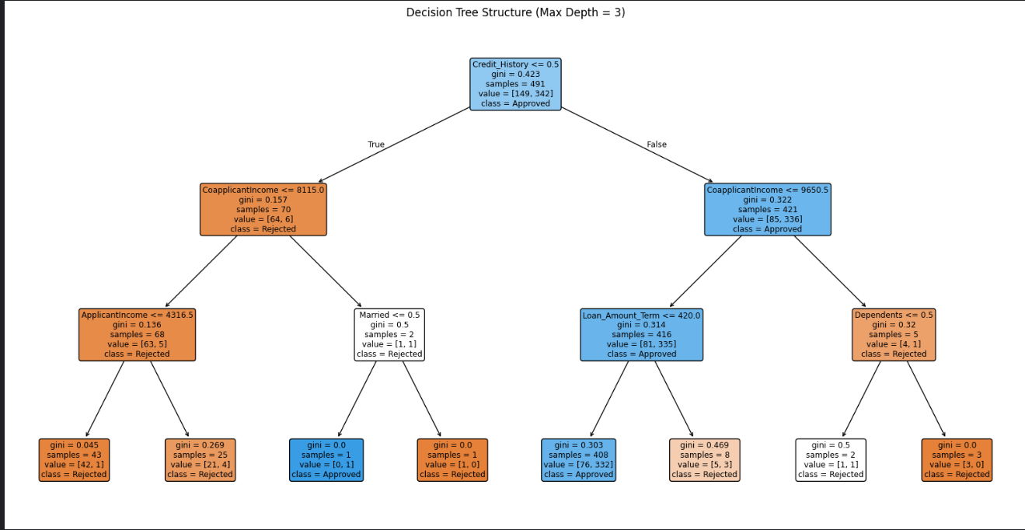
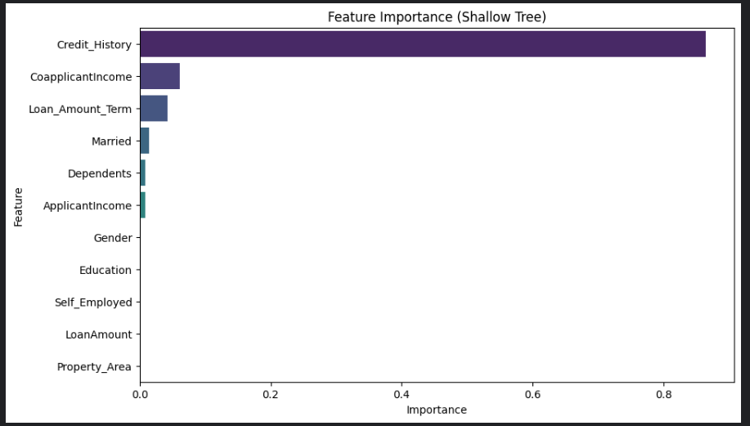

SUBMISSION REQUIREMENTS
- Python code (with student roll numbers)
- Screenshot of code
- Screenshot of outputs and graphs
- GitHub repository link

POST-LAB QUESTIONS (PROVIDE BRIEF ANSWERS TO THE FOLLOWING QUESTIONS)

Scenario 1 – K-Nearest Neighbors
- Why was feature scaling necessary?
Feature scaling was necessary because KNN is distance-based.
It calculates distances between points, so features with larger values (like area_mean) would dominate smaller ones (like smoothness_mean) if not scaled.

- How did model performance change with K?
For small K (1–3): Accuracy was lower (~90–93%) → likely overfitting.
As K increased (7–11): Accuracy improved (~95–96%).
After K = 11: Accuracy became stable (~96.5%).

- What value of K gave best results? Why?
K = 11 gave the best result (≈96.5% accuracy).

- What are limitations of KNN?
Slow for large datasets (must compute distance to all points).
Sensitive to feature scaling.
Sensitive to irrelevant features.
Memory-intensive (stores all training data).
Choosing K requires experimentation.

Scenario 2 – Decision Tree
- Which features influenced loan approval most?
Credit_History was the most influential feature (very high importance ~0.85).
CoapplicantIncome had small influence.
Loan_Amount_Term had minor influence.
Other features (Gender, Education, Self_Employed, Property_Area, etc.) had very little or almost no impact.

- How did tree depth affect performance?
Model | Train Accuracy | Test Accuracy
Shallow (depth=3) | ~0.80 | 0.764
Deep (unpruned) | ~1.00 | 0.691

- What signs of overfitting were observed?
Large gap between training and testing accuracy
- Train ≈ 100%
- Test ≈ 69%
- Difference > 0.30 (very high)
Lower Recall in deep tree
- Shallow recall = 0.95
- Deep recall = 0.775
More False Negatives
Deep tree misclassified more approved loans.

- Advantages of Decision Trees?
Easy to interpret and visualize
Shows clear decision rules (e.g., Credit_History split)
No need for feature scaling
Handles both numerical and categorical data
Provides feature importance
Can capture nonlinear relationship

Conceptual Questions
- Compare KNN and Decision Trees.
KNN
Lazy learner; stores all training data.
Predicts using nearest neighbors (distance-based).
No real training cost, slow prediction.
Needs feature scaling.
Decision Trees
Rule-based model using feature splits.
Learns during training; fast prediction.
Produces if-else decision rules.
No scaling usually needed.

- Which model is more interpretable? Why?
Tree structure = explicit logical rules (“if feature ≤ threshold → go left”).
You can trace a single prediction path from root to leaf.
Human-readable splits make feature influence clear.
KNN has low interpretability because:
Predictions depend on geometric relationships in high-dimensional space.
No symbolic rule or model parameters to inspect.

- Which model is more sensitive to noise?
KNN: Highly sensitive to noisy labels or outliers because predictions rely directly on nearby samples. One wrong neighbor can flip the class when k is small.
Decision Trees: Also sensitive, especially deep trees that overfit noise by creating very specific splits.

- Why is hyperparameter tuning important?
Hyperparameters control model bias–variance trade-off.
KNN → k, distance metric.
Decision Tree → max depth, min samples split, criterion.

- Why is confusion matrix preferred over accuracy alone?
Accuracy = single scalar; it hides error structure.
Confusion matrix gives:
True Positives, False Positives, True Negatives, False Negatives.
Enables precision, recall, F1, specificity analysis.

ASSESSMENT
Description | Max Marks | Marks Awarded
Pre Lab Exercise | 5
In Lab Exercise | 10
Post Lab Exercise | 5
Viva | 10
Total | 30
Faculty Signature

